Deployment and Integration Report
Project: Brew & Bloom — Coffee Shop POS
Repository: https://github.com/thabolebata894-ux/brew-bloom-coffee-shop
Date: 13 November 2026
Scope of this report: connecting the deployed React frontend to the deployed Express/Redis backend, and proving the connection works end to end.

0. Submission links
Item | Link
Frontend — submit this one | https://frontend-thabolebata894-1162s-projects.vercel.app
Frontend — short alias (same build) | https://frontend-ten-alpha-29.vercel.app
Backend API | https://brew-bloom-backend.onrender.com
Backend health check | https://brew-bloom-backend.onrender.com/api/health
Source code | https://github.com/thabolebata894-ux/brew-bloom-coffee-shop (private repository)

Do not use frontend-gbg4vs40w-…vercel.app. That is an older, frozen deployment that was built before the API address was configured; it can never reach the backend. Every frontend-<hash>-…vercel.app address is a snapshot of a single build, so only the two links above should be used for marking.
All checks below were repeated against the live deployment on 13 November 2026 and passed.

1. Deployed system
Component | Platform | URL | Status
Frontend (React + Vite) | Vercel | https://frontend-thabolebata894-1162s-projects.vercel.app | Live — Ready
Backend (Express + Redis) | Render | https://brew-bloom-backend.onrender.com | Live — {"status":"ok","database":"redis"}
Data store | Redis Cloud | REDIS_URL secret on Render | Connected

The frontend and backend are separate deployments. The browser loads the static React bundle from Vercel and every data request (/api/...) is sent to the Render API origin.
Browser
│ GET https://frontend-thabolebata894-1162s-projects.vercel.app → Vercel CDN → React bundle (dist/)
│ fetch https://brew-bloom-backend.onrender.com/api/*
▼
Express API (server.js) ──▶ Redis Cloud (menu, orders, tables, daily ticket counter)

2. How the two are connected
Layer | Setting | Value
Vercel → build | VITE_API_URL (Production and Preview) | https://brew-bloom-backend.onrender.com
Frontend code | frontend/src/api/api.js | import.meta.env.VITE_API_URL, with a production fallback to the Render origin
Local development | frontend/.env + Vite proxy | VITE_API_URL=http://localhost:4000, /api proxied to port 4000
Backend | app.use(cors()) | Access-Control-Allow-Origin: * — allows the Vercel origin
Backend port | process.env.PORT | Render-assigned port; 4000 locally
SPA routing | frontend/vercel.json | All non-asset paths rewritten to / so /staff etc. work on refresh

Change made during this work: frontend/src/api/api.js previously used only import.meta.env.VITE_API_URL || ''. If a build was made without the variable, requests were sent to the Vercel domain instead of the API and the site returned HTML where JSON was expected. Production builds now fall back to the deployed API origin, so no deployment can ship "unconnected" again.
const PRODUCTION_API_URL = 'https://brew-bloom-backend.onrender.com';
const FALLBACK_API_URL = import.meta.env.PROD ? PRODUCTION_API_URL : '';
const API_URL = (import.meta.env.VITE_API_URL || FALLBACK_API_URL).replace(/\/+$/, '');

3. Verification method
The site was driven with a headless Chrome browser (1440 × 900) against the production URL, not a local build:
- Load the customer page and wait for the menu to arrive from the API.
Add items to the cart, open checkout, and place a real dine-in order.
- Sign in to the staff portal and confirm the order appears on the POS board.
Cancel the order from the POS and confirm the table is released.
- Re-read the same records from the API to confirm what the browser saw is what Redis stored.
- No mocks, no local server: every screenshot below is the live deployment.

4. Screenshots
All screenshots are stored in screenshots/.

4.1 Customer home page
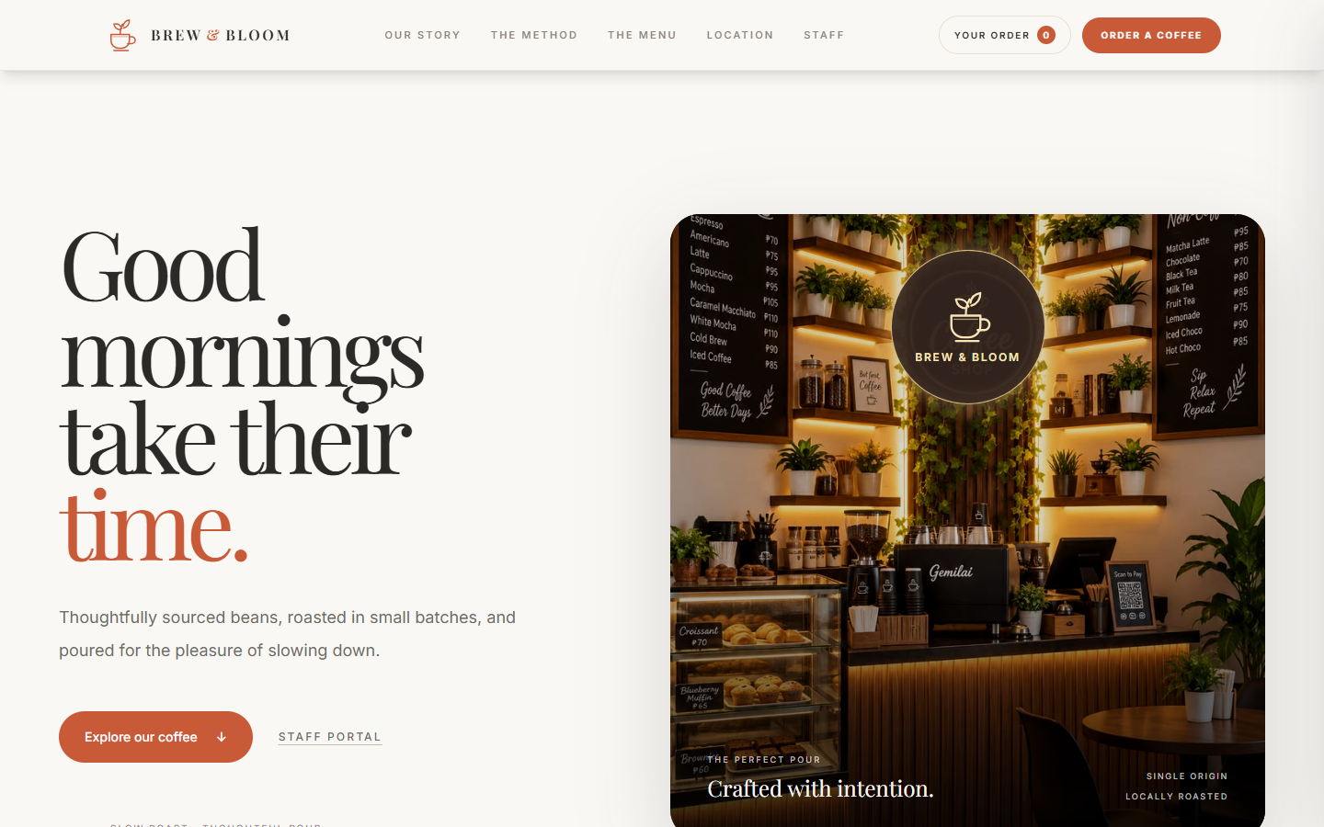
Figure: ../screenshots/01-home-hero.png
The React bundle is served by Vercel and the page renders with its brand assets.

4.2 Menu loaded from the backend API
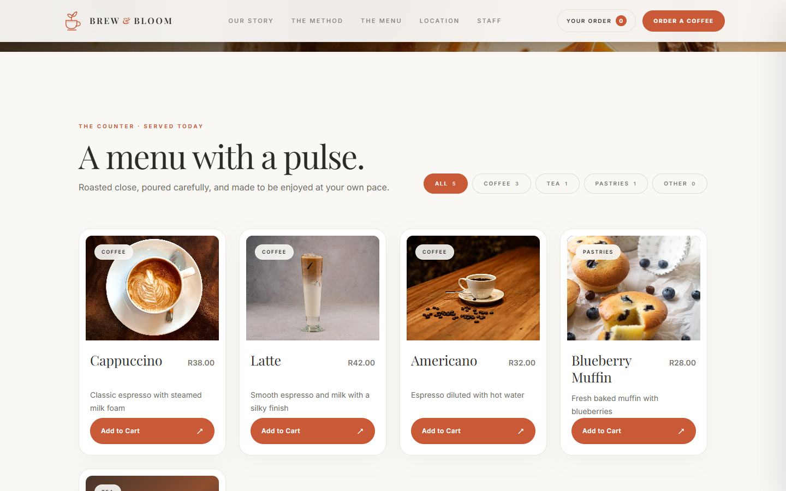
Figure: ../screenshots/02-menu-loaded-from-api.png
Five menu items returned by GET /api/menu — Cappuccino, Latte, Americano, Blueberry Muffin and Black Tea — with live prices in Rand. This is the direct proof that the frontend reaches the backend: the seed data only exists in Redis behind the Render service.

4.3 Cart drawer
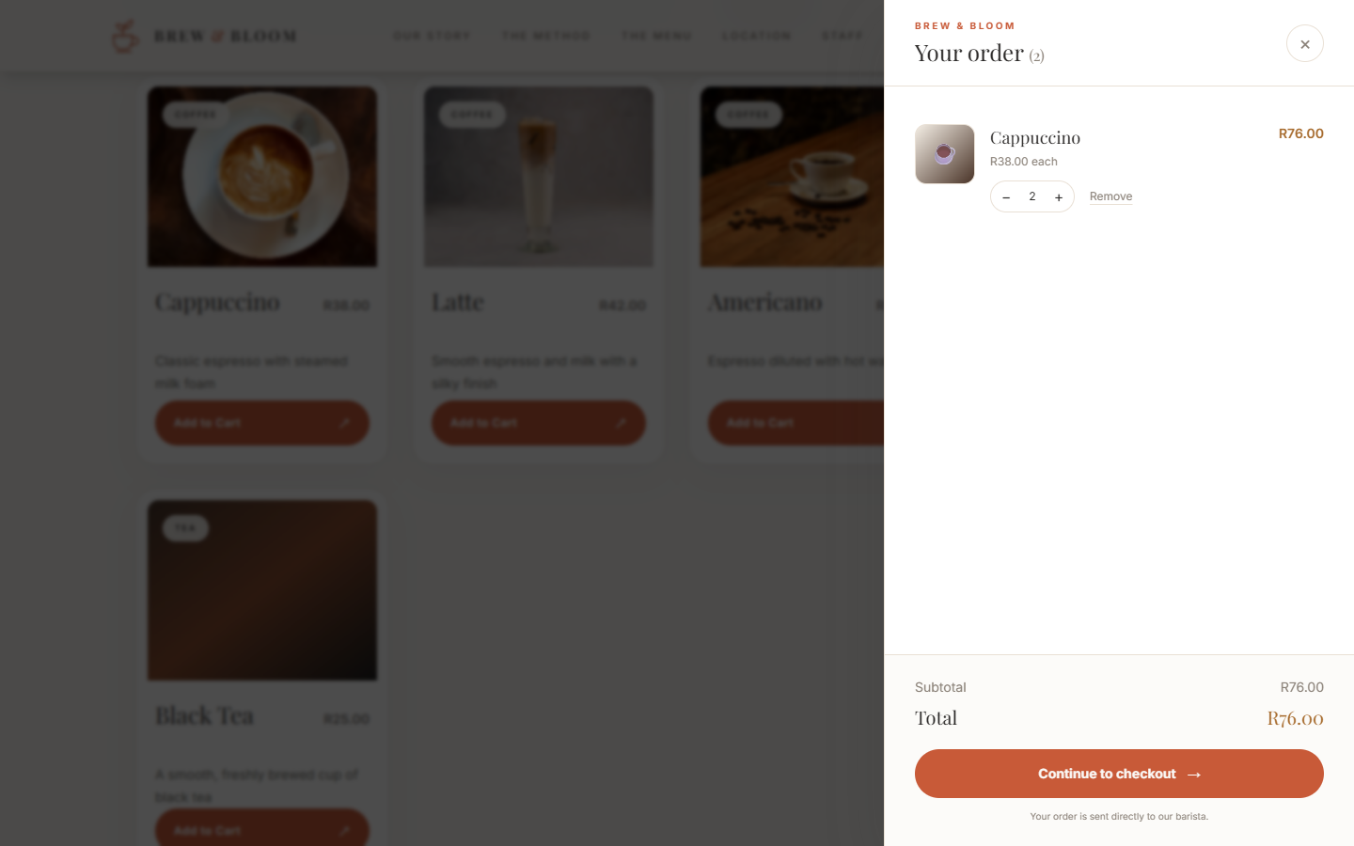
Figure: ../screenshots/03-cart-drawer.png
Quantity controls and the running total are calculated client-side from the API-supplied prices.

4.4 Checkout (dine-in)
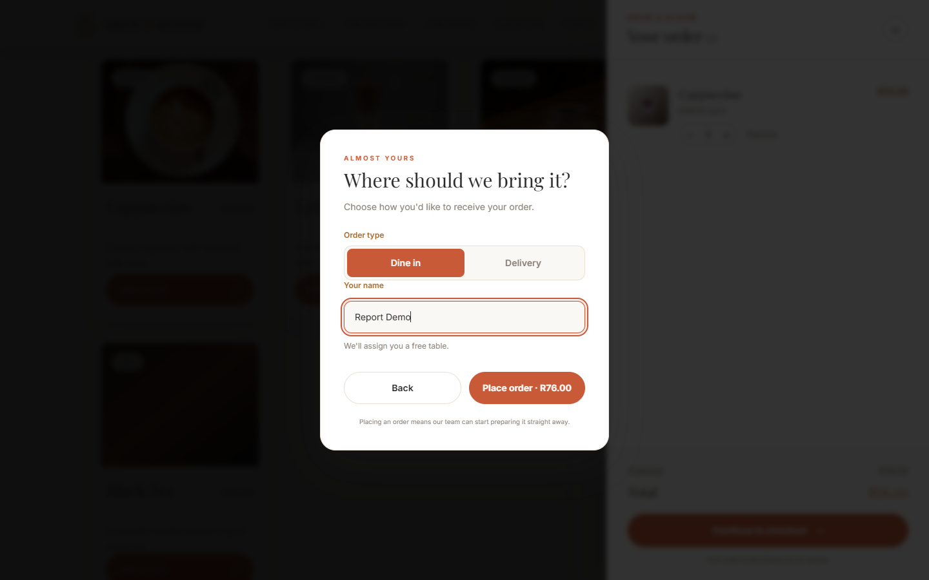
Figure: ../screenshots/04-checkout-dine-in.png
Dine-in orders are posted without a table number; the API assigns the next free table.

4.5 Order placed — ticket and table assigned by the API
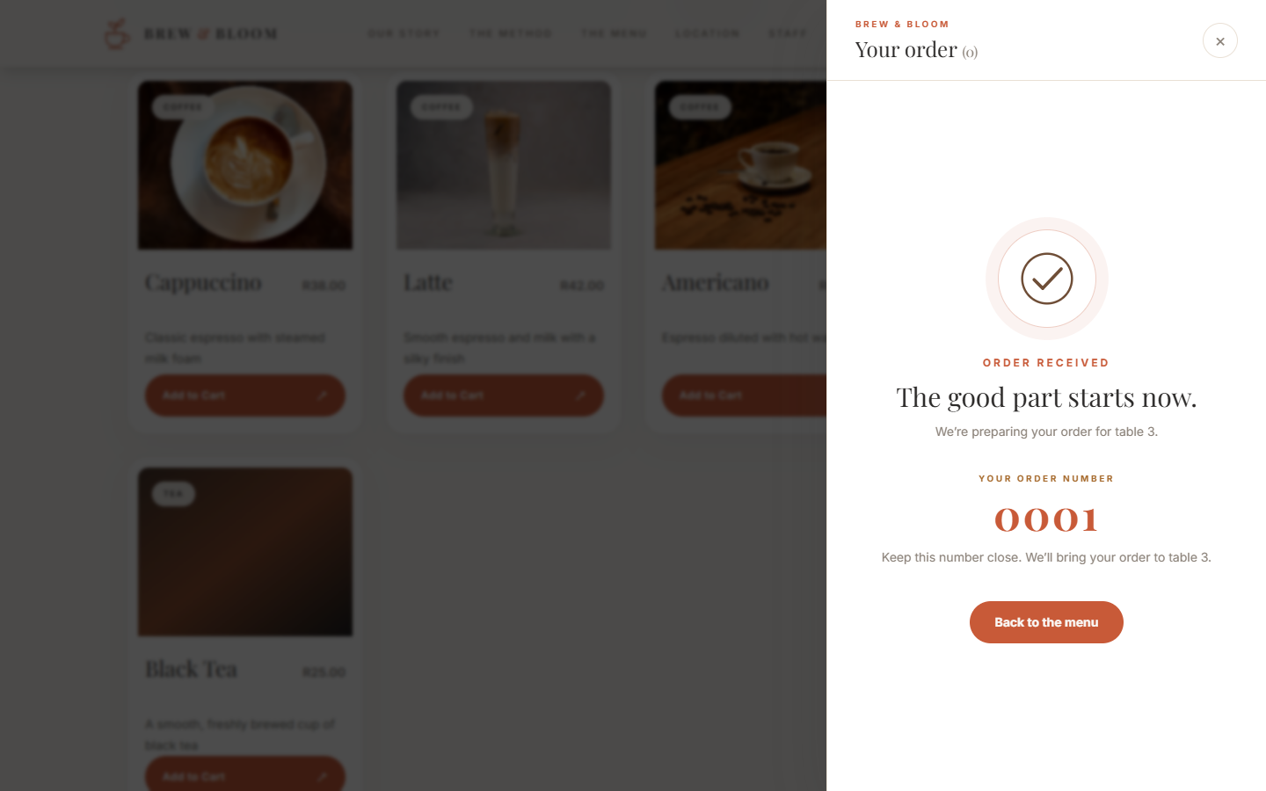
Figure: ../screenshots/05-order-confirmation.png
POST /api/orders succeeded and returned a server-generated daily ticket number (0001) and table (3). Both values exist only in Redis, so they cannot be produced by the frontend alone.

4.6 Staff login
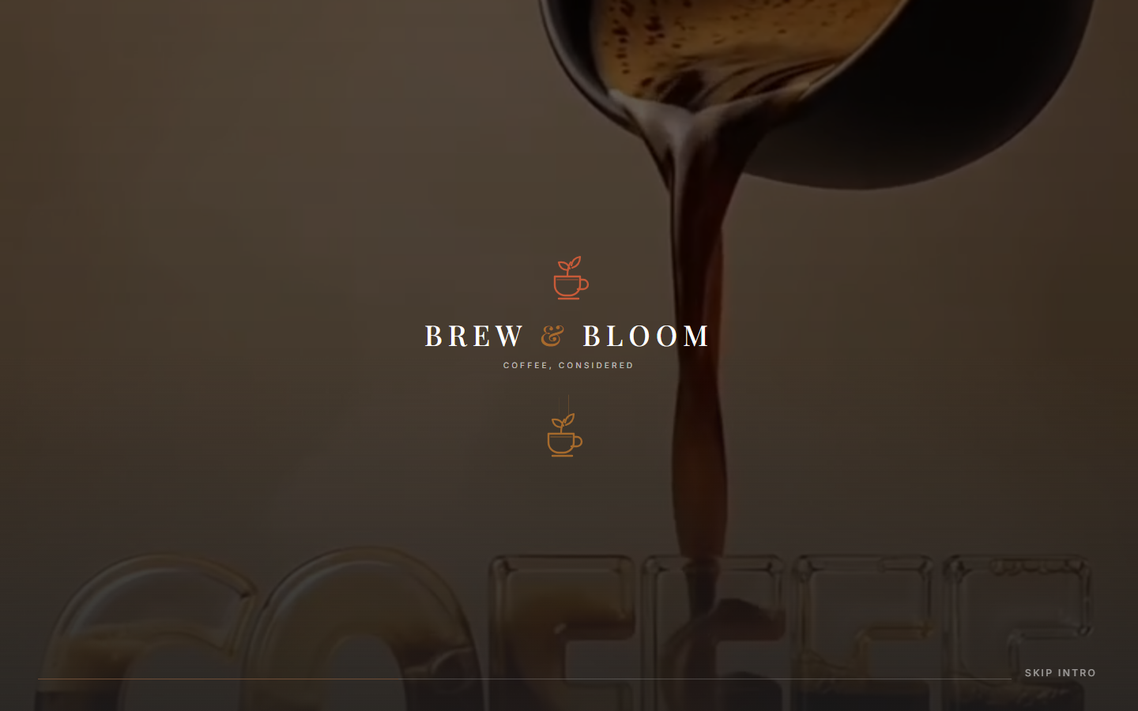
Figure: ../screenshots/06-staff-login.png

4.7 Staff point of sale
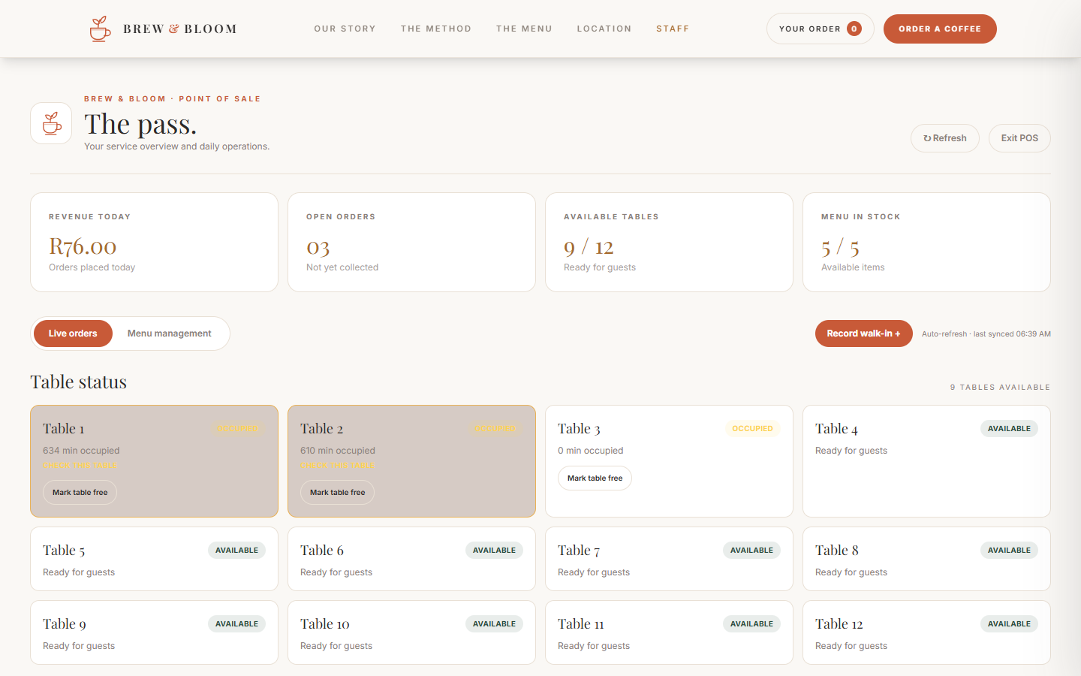
Figure: ../screenshots/07-staff-dashboard.png
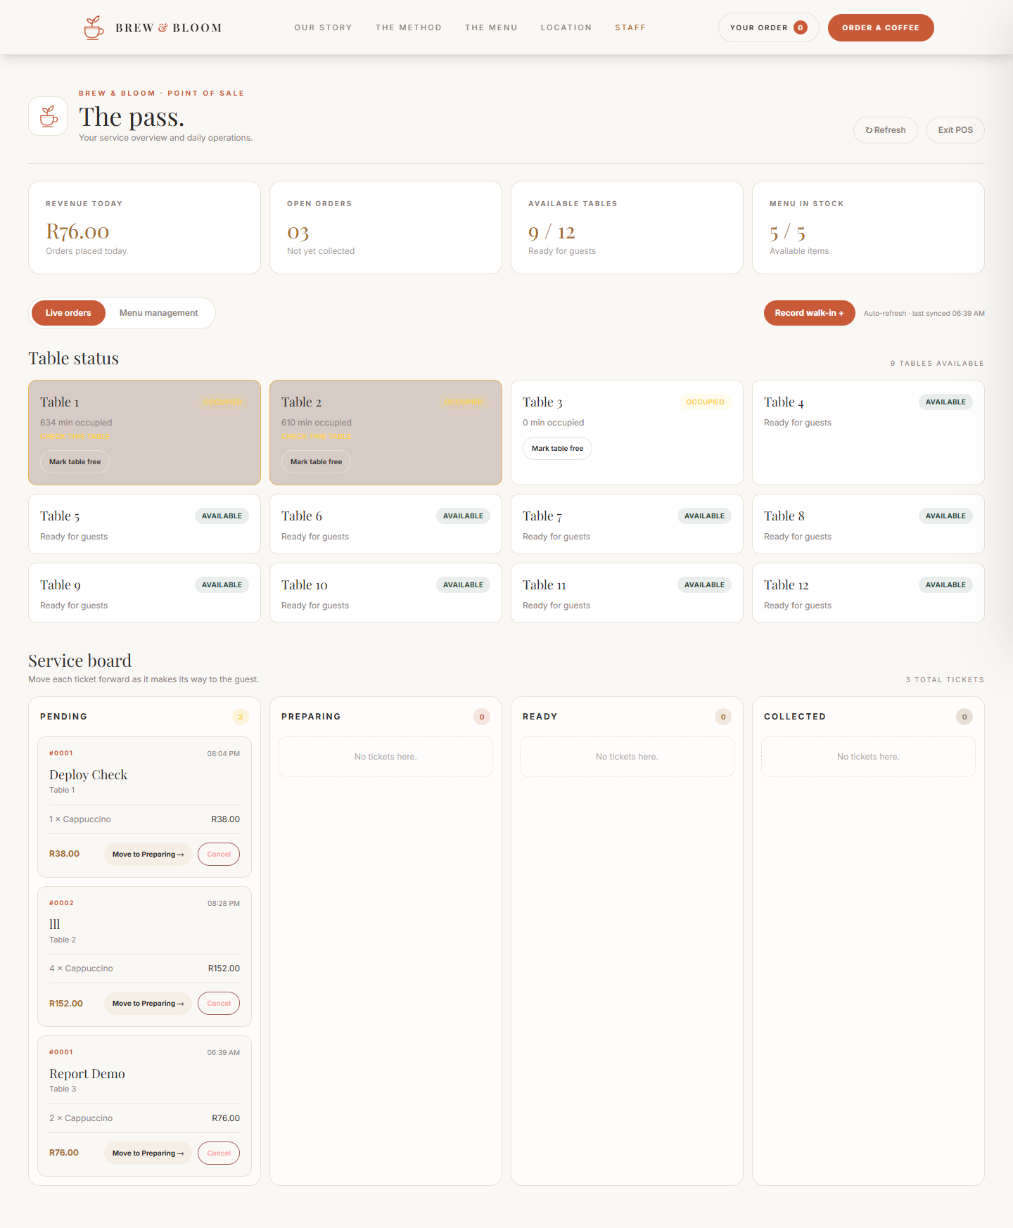
Figure: ../screenshots/08-staff-dashboard-full.png
The dashboard loads four endpoints in parallel (/api/menu, /api/orders, /api/tables, /api/health) and shows the order placed in section 4.5 on the board, the occupied table, and today's revenue.

4.8 Backend endpoints
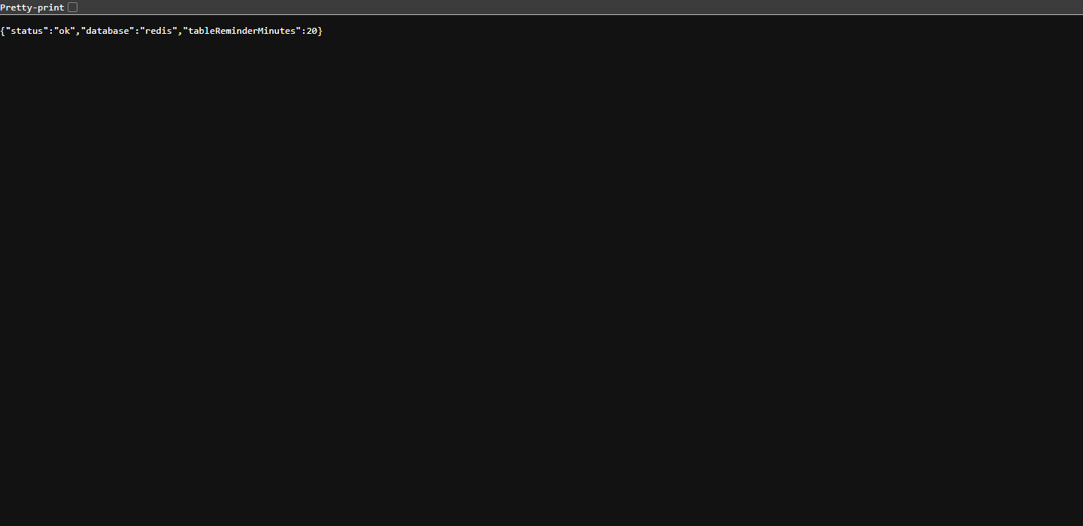
Figure: ../screenshots/09-backend-health-endpoint.png
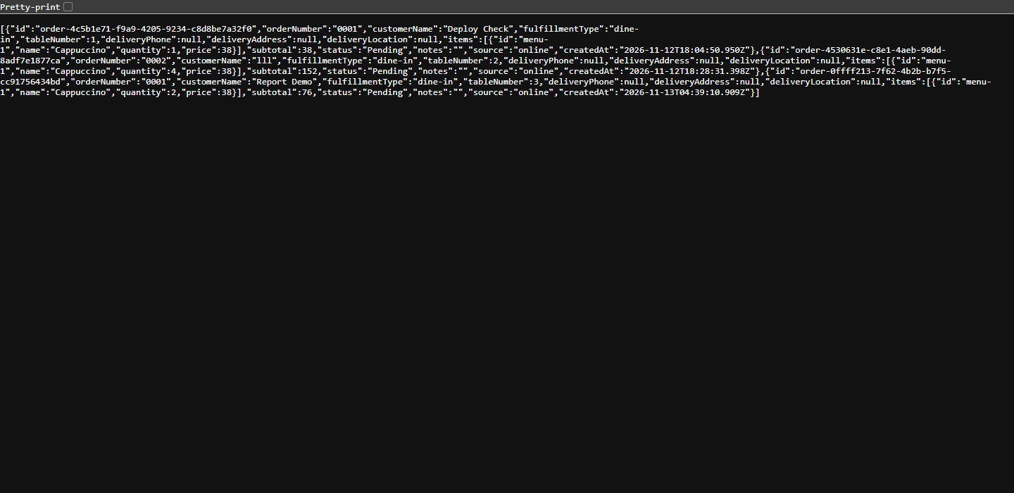
Figure: ../screenshots/10-backend-orders-endpoint.png
GET /api/health returns {"status":"ok","database":"redis","tableReminderMinutes":20} and GET /api/orders returns the stored order including the calculated subtotal.

4.9 Order cancelled and table released
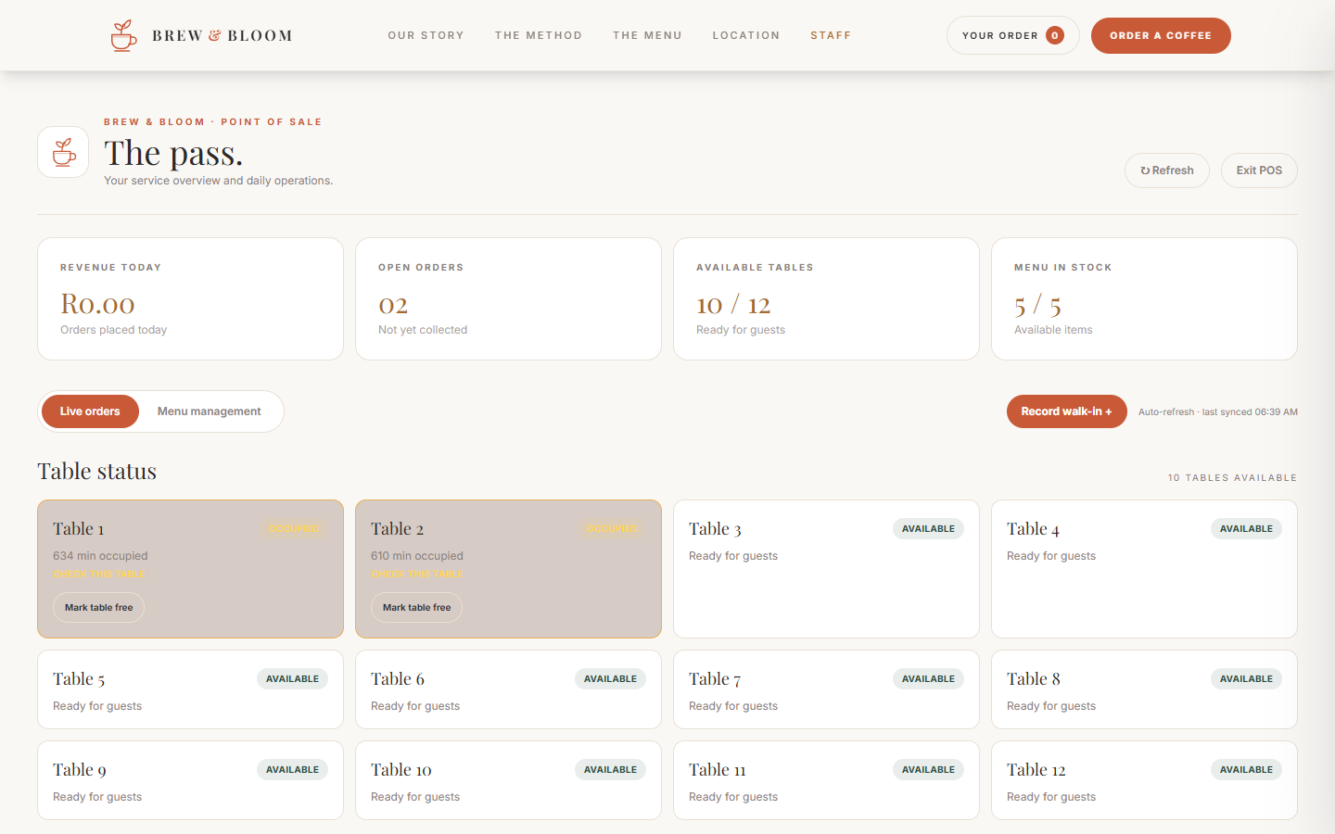
Figure: ../screenshots/11-order-cancelled-table-released.png
PATCH /api/orders/:id/cancel set the order to Cancelled and PATCH /api/tables/3/release behaviour returned table 3 to the available pool.

5. Test results
Check | Expected | Observed | Result
Frontend reachable | 200 HTML | 200, title "Brew & Bloom — Coffee House" | Pass
API origin in built bundle | Render URL | https://brew-bloom-backend.onrender.com | Pass
GET /api/health | ok + Redis | {"status":"ok","database":"redis","tableReminderMinutes":20} | Pass
GET /api/menu from browser | 5 items | 5 items rendered | Pass
CORS preflight for POST /api/orders | 204 + allow origin | 204, Access-Control-Allow-Origin: *, GET,HEAD,PUT,PATCH,POST,DELETE | Pass
Place order through the UI | 201 + ticket | Order 0001, table 3, subtotal R76.00 | Pass
Order visible in POS | Appears on board | Displayed in staff dashboard | Pass
Cancel order from POS | Status Cancelled | status: "Cancelled", cancelledAt set | Pass
Table released after cancel | Available | Table 3 available, orderId: null | Pass
SPA deep links (/staff, /menu) | 200 | 200 | Pass
Browser console / network errors | None | None during the flow | Pass

Result: the frontend and backend are connected and working end to end.

6. Issues found and resolved
- Stale deployment looked "disconnected".
- The deployment URL frontend-gbg4vs40w-…vercel.app was built before VITE_API_URL existed. Its bundle had no API origin, so /api/menu was answered by Vercel's SPA rewrite with index.html (HTTP 200, text/html), and the UI reported that it could not load the menu. That URL is immutable; the supported entry point is the alias https://frontend-ten-alpha-29.vercel.app.
No API URL in Preview builds.
VITE_API_URL existed only for Production. It is now set for Preview as well, so branch/preview deployments also reach the API.
- Deployments from the local repo were blocked.
- Vercel reported: *"The deployment was blocked because the commit author doesn't have permission to create deployments for this project."* The local git author is the placeholder YOUR-thabolebata89@gmail.com, which is not the Vercel account (thabolebata894@gmail.com). The release was published from a clean copy; to deploy straight from the repo, set the real address once:

- git config --global user.email "thabolebata894@gmail.com"

- and commit again (existing commits keep the old author).

7. Known limitations
- Render free tier idles after inactivity; the first request of the day can take ~50 seconds. The menu shows a retry button if that request times out.
Staff login is a demo gate only. Any non-empty ID and password opens the POS; there is no authentication, session handling or role check.
- No payment step. Totals are calculated but no payment provider is integrated.
Redis on the free tier has no persistence guarantee; menu and order history can be lost on a Redis restart.
- Menu item prices are validated server-side (minimum R20.00) but the public API has no write authorisation — POST/PUT/DELETE /api/menu are open. This is acceptable for a marking demo, not for production traffic.

8. Reproducing the verification
# 1. Backend health
curl https://brew-bloom-backend.onrender.com/api/health

# 2. Menu served to the frontend
curl https://brew-bloom-backend.onrender.com/api/menu

# 3. CORS for the deployed frontend origin
curl -i -X OPTIONS https://brew-bloom-backend.onrender.com/api/orders \
-H "Origin: https://frontend-thabolebata894-1162s-projects.vercel.app" \
-H "Access-Control-Request-Method: POST" \
-H "Access-Control-Request-Headers: content-type"

# 4. Frontend build configuration
vercel env ls --cwd frontend
To redeploy the frontend after a change:
cd frontend
vercel --prod
VITE_API_URL is already configured in the Vercel project, so no additional environment setup is required.

End of report.

